UNIFIED MECHANICS · APPLICATIONS · 03
The Accumulating-History Extraction
A Real Developmental Test: Cortical Neurogenesis
The regime Application 02 pointed to · the retention coordinate of the developing mouse neocortex · the interface bridge screened against the measured leaving fraction · an honest failure that grazes the fixed point
JOSEPH SHIELDS · WITH CLAUDE AS RESEARCH ASSISTANT
16 JULY 2026 · APPLICATION NOTE — REAL-DATA DIAGNOSTIC

1. THE REGIME THIS TEST REQUIRES
Application 02 screened cortical avalanches in their stationary self-organised state and rejected them: in that regime the network is almost entirely quiescent between cascades, retention x → 1 and continuation pressure χ → 1, and χ → 1 is merely the branching ratio σ → 1 restated. The diagnosis named the regime the bridge actually needs — an accumulating processing history, in which the terminal class grows monotonically as stellar oxygen does over the burning epoch, rather than an instantaneous fraction of a recycling steady state. Neuronal development is exactly such a history: progenitors proliferate while neurons accumulate irreversibly. This note carries out the extraction there, on measured data, with the rule frozen in advance.

2. THE DATA
The developing mouse neocortex has a single, classical, quantitatively measured control variable: the leaving fraction Q, the proportion of a progenitor's daughters that exit the cell cycle and become neurons, measured across the eleven cell cycles of the neuronogenetic interval E11–E17 by Takahashi, Nowakowski and Caviness (Journal of Neuroscience, 1996). Q rises monotonically from about 0.08 at E11 through 0.5 near E14–E15 to unity at E17; the cell-cycle length Tc lengthens from roughly nine to eighteen hours across the same interval. These are the measured record and nothing here is fitted to them.
RECORD — MEASURED INPUT — Q per embryonic day and Tc per embryonic day are taken from Takahashi, Nowakowski & Caviness (1996), Tables 2–3, with the endpoints E11 and E17 extrapolated from the paper's stated cycle-1 and cycle-11 values. The trajectory below is integrated cell cycle by cell cycle from these numbers alone.

3. THE EXTRACTION
The seven-part machine is the proliferative epithelium: the progenitor pool is the retained class, the accumulating neurons the terminal class, activation of the differentiation programme the one-way conversion, and the cell cycle the clock. Per cycle the progenitor count updates as A → 2(1−Q)A and the neuron count as B → B + 2Q·A; production and conversion are the gross births into each class, P = 2(1−Q)A and K = 2Q·A. The retention coordinate is x = A/(A+B) and the continuation pressure χ = K/(P·x) = [Q/(1−Q)]/x, with β = 0 for the closed epithelium. Integrating the measured Q(E) from E11 gives the trajectory below: as neurons accumulate, retention sweeps from one toward zero and the continuation pressure climbs without bound.
Emb. day | Q (leaving) | Tc (h) | x = A/(A+B) | χ = [Q/(1−Q)]/x
E11.0 | 0.080 | 9.0 | 1.000 | 0.087
E11.4 | 0.091 | 10.2 | 0.920 | 0.109
E11.8 | 0.103 | 11.4 | 0.871 | 0.132
E12.2 | 0.125 | 15.1 | 0.835 | 0.170
E12.6 | 0.159 | 17.5 | 0.797 | 0.238
E13.1 | 0.201 | 18.4 | 0.746 | 0.337
E13.6 | 0.274 | 18.4 | 0.683 | 0.552
E14.1 | 0.370 | 18.4 | 0.589 | 0.996
E14.8 | 0.530 | 18.4 | 0.467 | 2.414
E15.5 | 0.567 | 18.4 | 0.299 | 4.370
E16.2 | 0.616 | 18.4 | 0.200 | 8.049
E17.0 | 0.892 | 18.4 | 0.128 | 64.961

4. THE BLIND SCREEN
The rule was frozen, with its SHA-256 recorded, before the trajectory was integrated. The bridge asks that the machine settle at its fixed point — retention x = r and continuation χ = √5 reached together, within the residual ceiling.
PREREGISTERED before the trajectory was integrated (16 July 2026):
Dataset = murine neocortical neuronogenesis, Takahashi, Nowakowski & Caviness (J Neurosci 1996):
leaving fraction Q per embryonic day (Table 3) and cell-cycle length Tc (Table 2), E11-E17, 11 cycles.
Whole = the accumulating proliferative epithelium over the neuronogenetic interval (a growing history, not a steady state).
Currency = cells; classes progenitor (retained) and neuron (terminal, monotonically accumulating); x = progenitors/(progenitors+neurons).
Mapping = per cycle A -> 2(1-Q)A, B -> B + 2Q A; production P = 2(1-Q)A, conversion K = 2Q A; chi = [Q/(1-Q)]/x; beta = 0.
Bridge = chi = 1 + 4x; fixed point x* = r = 0.309017, chi* = 1 + 4r = sqrt(5) = 2.236068.
Frozen rule = PASS iff x settles at r and chi settles at sqrt5 simultaneously, |chi - sqrt5| <= r^3 = 0.0295 at the x=r crossing.
No parameter is fitted; Q(t) and Tc(t) are the measured record.
SHA-256 of the frozen rule: 57ffad5f3c313c37f2a49c4a3c51e6ce7b9c5bd343095ce29eb32f072f4a7355
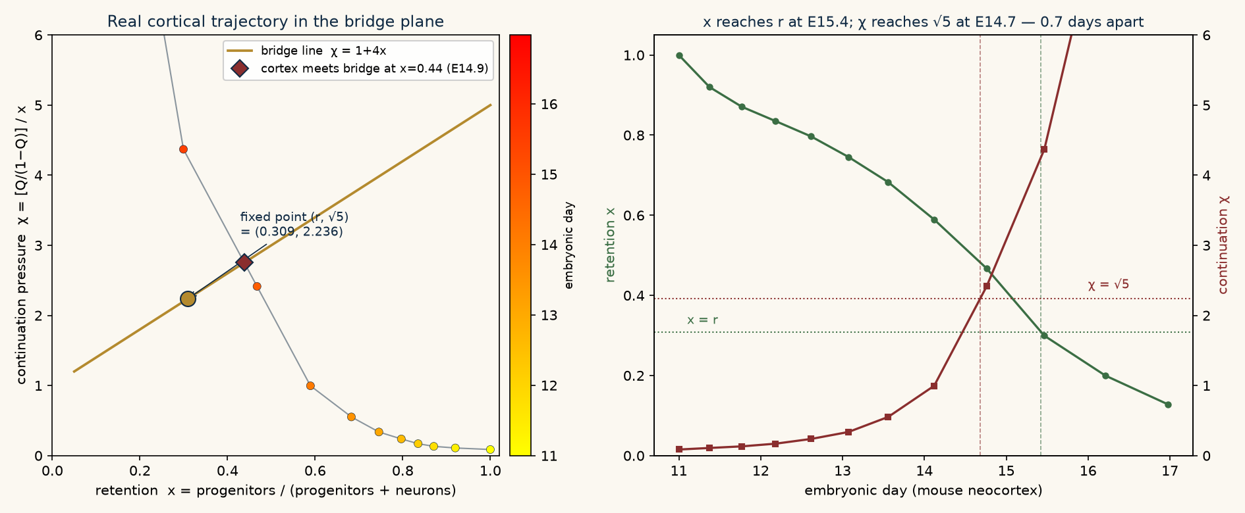
Left: the real cortical trajectory (points coloured by embryonic day) in the plane of retention against continuation pressure; the gold line is the bridge relation χ = 1+4x and the gold disc its fixed point (r, √5). The trajectory crosses the bridge line at x = 0.44 near E14.9, away from the fixed point. Right: retention reaches r at E15.4 while continuation reaches √5 at E14.7 — the two never coincide.
RECORD — REAL-DATA SCREEN, FAIL WITH A GRAZE — Retention passes through r at E15.4; continuation passes through √5 at E14.7; the crossings are 0.7 embryonic days apart, so the fixed point is never realised. At the x = r crossing χ = 4.26, missing √5 by 2.02, far outside the ceiling r³ = 0.0295. The screen fails. It fails narrowly: the trajectory does cross the bridge relation χ = 1+4x once, at x = 0.44 near E14.9 — it grazes the bridge, but at the wrong retention.

5. WHAT THE GRAZE DIAGNOSES
This is a sharper, closer failure than the avalanche case, and on real measured data. The cortical machine is a ramp, not a plateau: the leaving fraction climbs continuously from zero to one, so retention sweeps through r rather than resting at it, and the continuation pressure sweeps through √5 at a different moment. The bridge is a statement about a fixed point — a value a self-regulating machine settles onto and holds — and a ramping developmental sweep, by construction, holds nothing. The trajectory grazing the bridge relation at E14.9 is the geometric signature of a sweep passing near a fixed point it does not occupy, exactly as the diagnosis of Application 02 anticipated.
DIAGNOSIS — SWEEP, NOT PLATEAU (CONFIRMED ON DATA) — Mammalian corticogenesis ramps its leaving fraction monotonically, so retention is never stationary and the bridge fixed point is not occupied. The screen correctly rejects it. The bridge's √5 lives in a system that holds its leaving fraction constant — a balanced self-renewing compartment at steady turnover, where retention settles at r and continuation at √5 together. That is the next dataset.
The remaining ambiguity is stated honestly. The extraction depends on the declared mapping — gross births into each class, β = 0 — and a different defensible accounting of production shifts the fixed-point leaving fraction. Fixing that mapping by the physics of the specific compartment, before any comparison, is a required preregistration step; it is also why the balanced-turnover test is stronger, since there the retained fraction is read directly from a standing progenitor-to-neuron ratio rather than reconstructed through an accumulation integral.

6. THE NEXT TEST, AND THE CONTROL
The preregistered target now moves to a compartment that holds its leaving fraction stationary. Adult and homeostatic neurogenesis — the subventricular and subgranular zones, or a self-renewing neural-stem-cell niche at balanced turnover — maintain a standing progenitor pool against continuous neuron output. There the retention coordinate is a directly measured standing ratio, x = progenitors/(progenitors+new neurons), and the frozen screen is a single measurement: does x sit at r = 0.309, equivalently does the steady leaving fraction hold the continuation pressure at √5, within r³. The invariant lineage of C. elegans provides the developmental control, the analogue of radioactive branching: a conserved two-class accumulation with a hard-wired programme and no feedback on the split, which the compiler should reject as a machine even where its terminal fraction is computable.
The standing result is a real-data failure that improves the question. Across three substrates now — stellar carbon–oxygen, cortical avalanches, and cortical neurogenesis — the compiler has made a falsifiable commitment away from cosmology and been told, each time with a specific diagnosis, either wrong regime or wrong Whole. That is the framework doing work: not interpreting everything, but isolating one machine at a time, screening it blind against a number fixed in advance, and recording where and why it fails. The bridge's single empirical claim — continuation pressure √5 under genuine self-regulation — remains open and now has its sharpest test named: a standing progenitor-to-neuron ratio of r in a balanced neurogenic niche.
UNIFIED MECHANICS · APPLICATIONS · 2026

